图示

AI 生成的内容可能不正确。

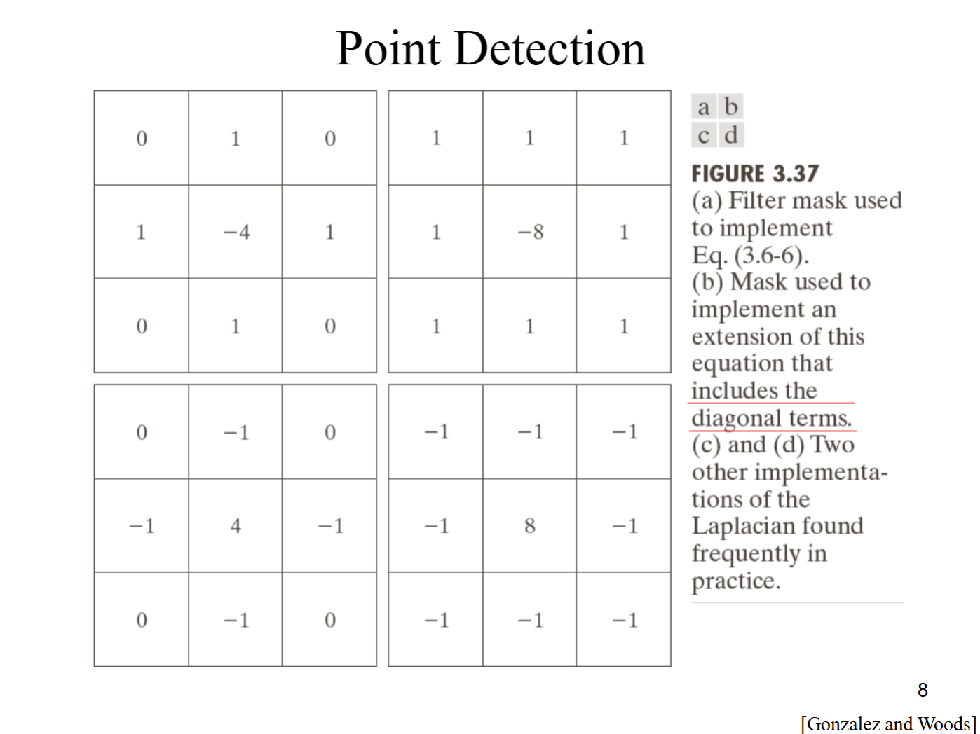

Edge Detection

First derivative

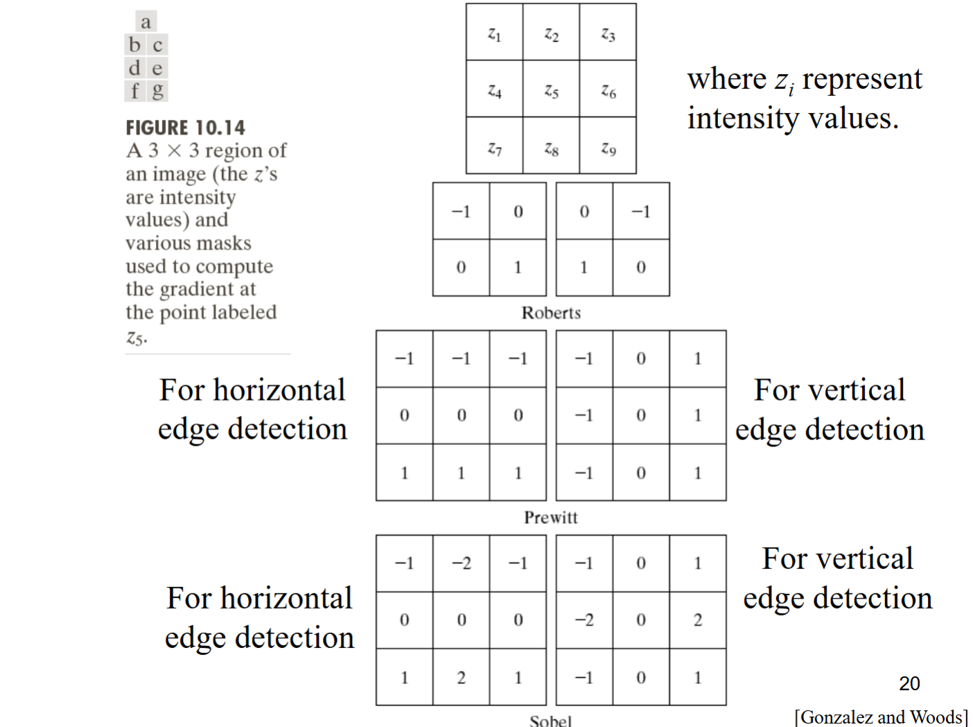

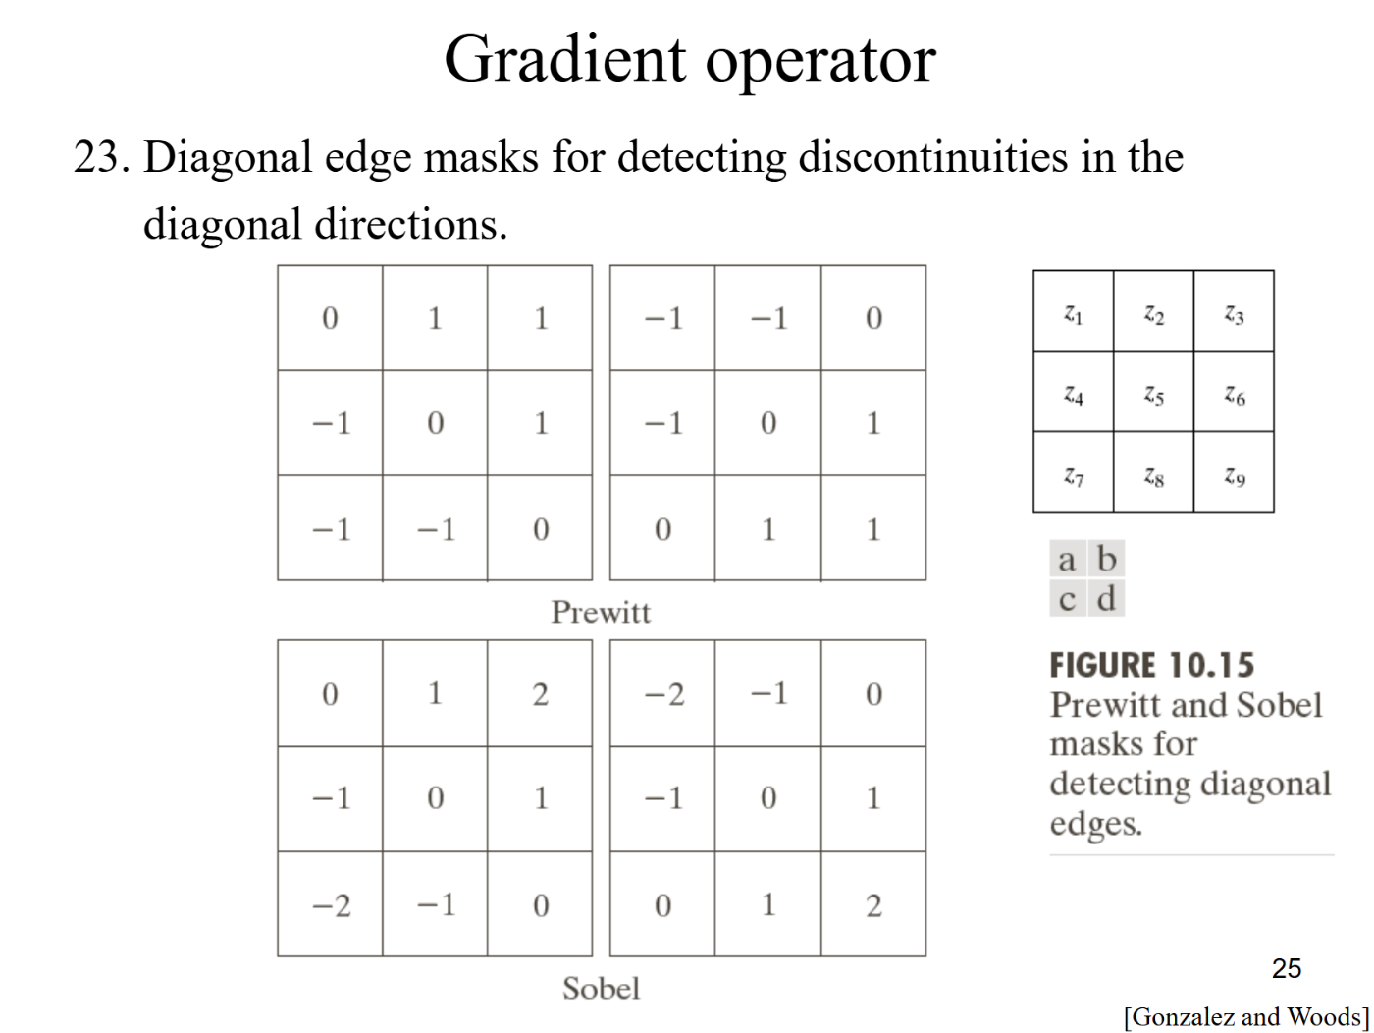

文本

AI 生成的内容可能不正确。

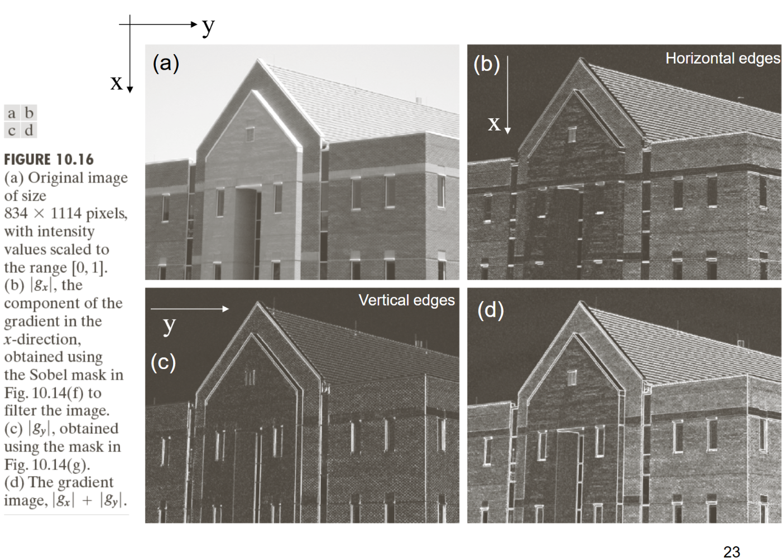

图示

AI 生成的内容可能不正确。

Second derivative

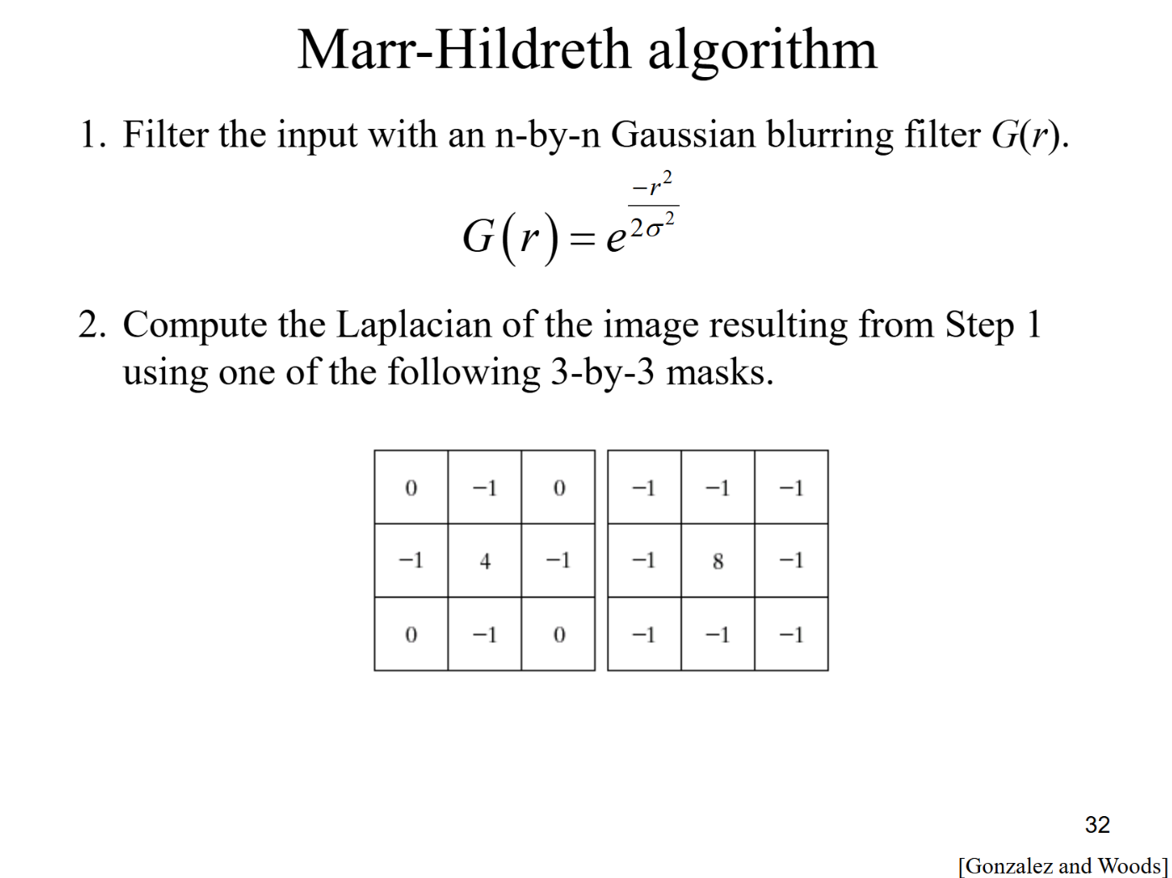

文本

AI 生成的内容可能不正确。

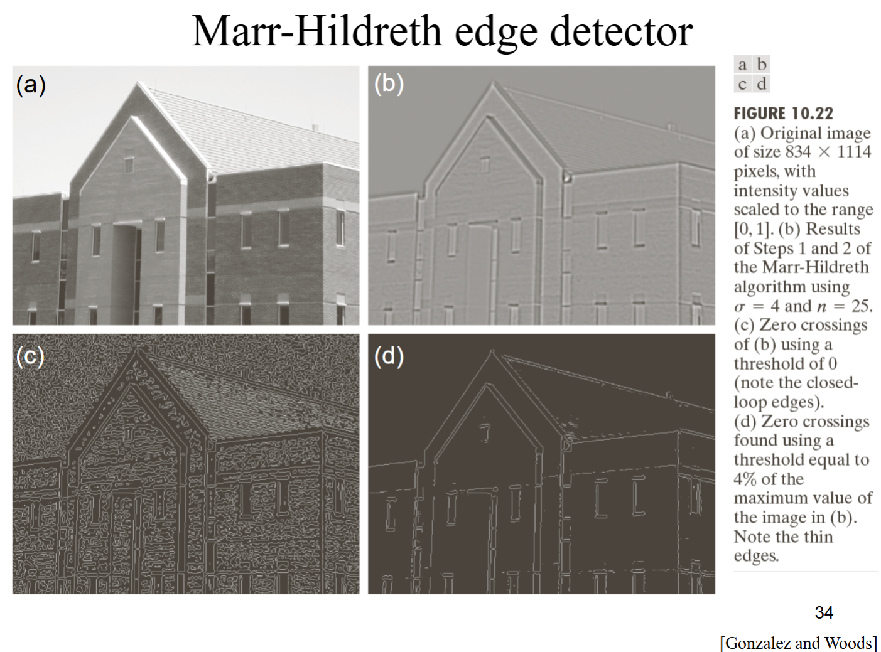

If precise edge localization is more important and noise is not a significant issue, the second derivative might be preferred. On the other hand, if the goal is to capture broader edge details with some tolerance for noise, the first derivative might be sufficient.

Canny edge detector

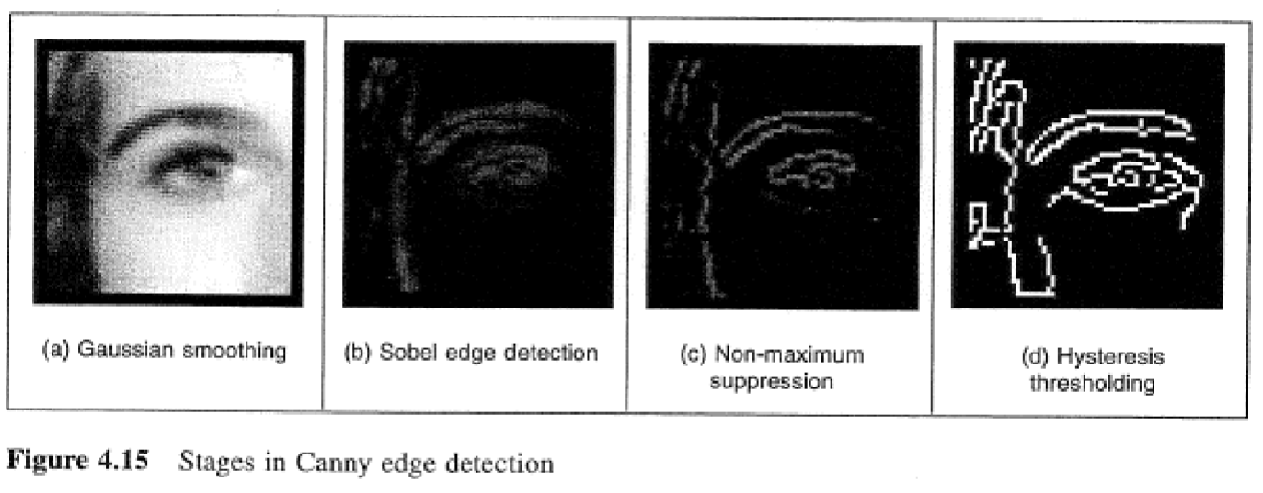

A Gaussian filter followed by the Sobel operator is often referred to an approximation of an optimal filter.

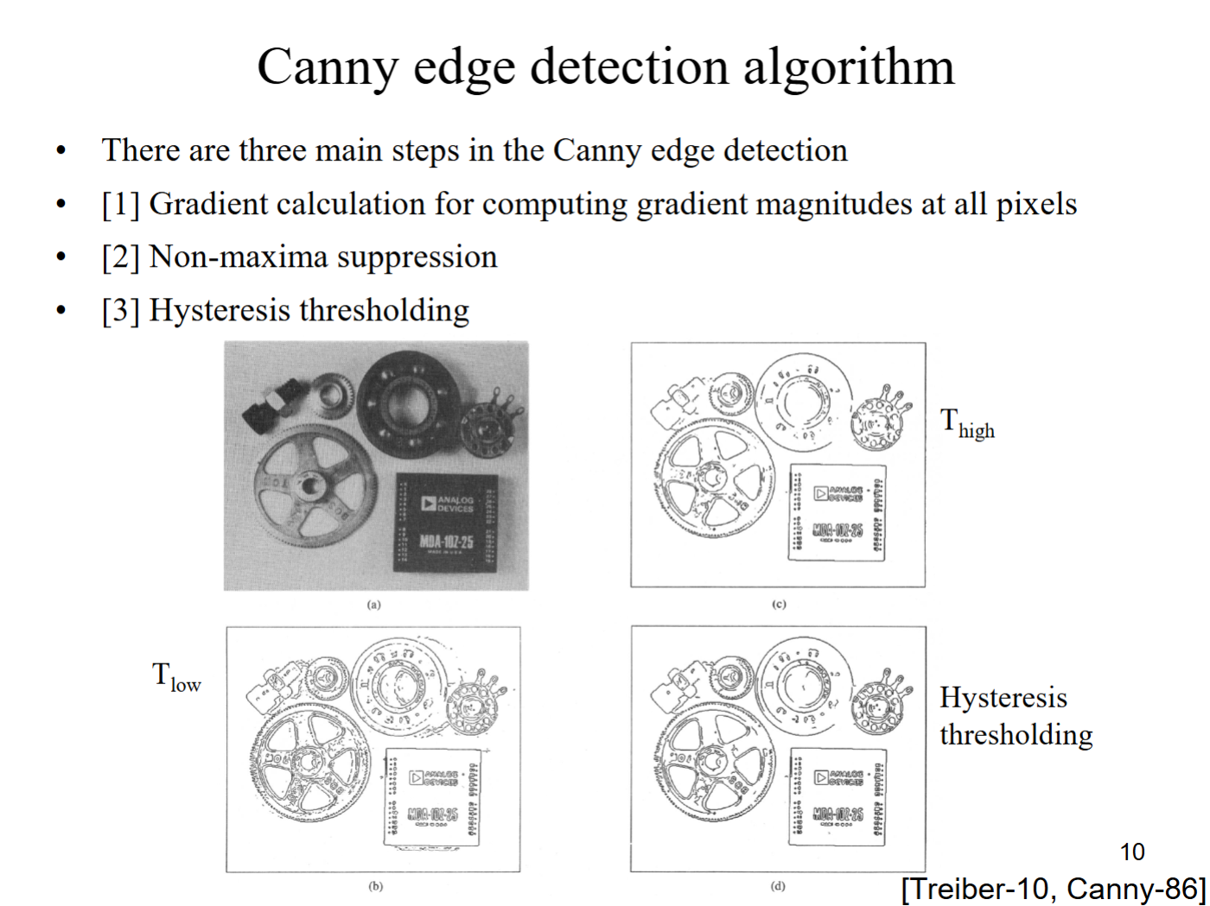

Non-maximum suppression:

文本

AI 生成的内容可能不正确。

Hysteresis thresholding:

文本

AI 生成的内容可能不正确。

文本

AI 生成的内容可能不正确。

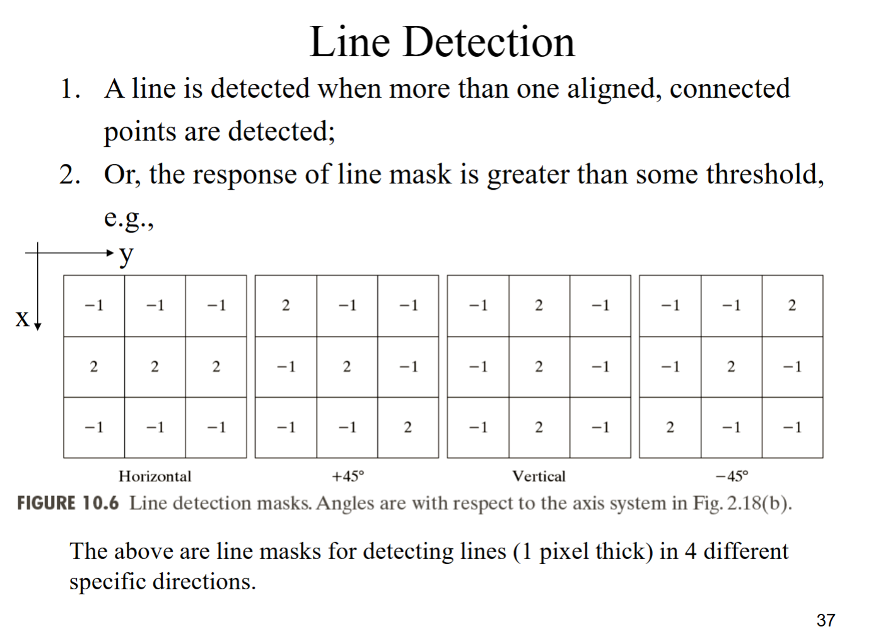

文本

AI 生成的内容可能不正确。